Experimental research on mechanical performance of the lightweight composite slabs
Huihui Zou, Juntao Wang, Xintang Wang
Department of Civil Engineering, Ningbo University, Ningbo 315211, China
wxt196322@126.com
Abstract. The static mechanical property of a new type of lightweight composite slabs is experimentally studied. The test results show that the composite slab has better entirety and greater bearing capacity, and the restraint at the two ends of the composite slabs has greater effect on bearing capacity of the slabs presented here. It is seen that the failure modes of the composite slab include cracking of concrete and local buckling of the thin-walled steel beams. The results also show that the composite slab works elastically as if the equivalent uniform load applied to the upper surface of the slab is less than 5kN/m².
- Introduction
To reduce the dead weight of the floor, it can be replaced by ceramsite concrete instead of ordinary concrete with gravel as coarse aggregate to form profiled steel plate - lightweight aggregate concrete composite floor[1-2]. The light steel truss-profiled steel sheet concrete composite floor was presented and the mechanical performance of it has been experimentally studied, and the combined action of the light steel trusses and the lightweight aggregate concrete has been studied[3], however the lightweight precast concrete panels was not considered in the paper. The laminated composite floor was studied [4], in which the occlusal effect between the upper laminated plates and precast panel was discussed to obtain the effective construction. Based on the existing papers, mechanical property of thin-walled steel truss-ceramsite concrete composite slabs was studied[5], in which the thin-walled steel truss as bearing beam was considered, but there was still some deficiencies for engineering application.
It follows that research on the lightweight prefabricated composite floor needs to be further studied. Hence, the lightweight composite slab was put forward, which consists of H-type thin-walled steel beams and lightweight concrete including the precast panels and the post-pouring layer. The composite slabs also have advantages of no formwork support, being lighter weight and factory prefabrication, et al. For application of the slabs in engineering, the mechanical properties of it is studied on basis of experiments, and a set of valuable suggestions are obtained.
- Construction and Geometrical Dimensions of Specimens
The construction and geometrical dimensions of the composite slabs are shown in Fig.1. It is noted that the slab specimens consist of the thin-walled steel skeleton which also is formed with H-type main steel beams and steel channels, lightweight precast panels set upon the steel skeleton, shear keys connected to the main steel beams and post-pouring concrete layer.
It is especially noted that the geometrical dimensions of cross-section of the thin-walled steel beams, steel channels and dimensions of the precast panels are shown in Fig.2. It is seen that the thickness of steel plate of the main steel beams and the steel channels is 0.6mm, and thickness of the precast panels is 40mm, and depth of groove of the precast panel is 10mm.

Fig.1 Construction and geometrical dimensions of specimens
(a) Cross section of main beam (b) Cross section of steel channel (c) Precast panel
Fig. 2 Geometrical dimensions of elements

It is noted that the main steel beams of three specimens are supported at the support beam as shown in Fig.1. Each secondary beam (steel channel) is connected with main steel beam and the support beam. The mechanical properties of the materials used are taken as: yield strength and elastic modulus of steel are f_{y}= 146MPa, Es=2.06×10⁵MPa, respectively, and cube strength standard value and elastic modulus of lightweight concrete are $σ_{c}=41.2MPa$ and Ec=2.17×10⁴MPa, respectively.
- Test Results and Discussions

Description of specimens
Static loading tests of three composite slab specimens as shown in Fig.1 are finished. The loading point and the measuring points of displacements are shown in Fig.3.
The specimens are denoted as SJ1, SJ2 and SJ3, for which the constraint conditions for them are different. In particularly, two ends of the main steel beams of specimens SJ1 and SJ2 are all simply supported, and four corners of specimen SJ2 are restrained in vertical direction, however two ends of the main steel beam of specimen SJ3 are fixed support. All the other parameters of three specimens are the same with each other as shown above. Loading scene of the specimens is shown in Fig.4. It is denoted that the measuring point of the relative displacement shown in Fig.3(a) is used to measure the horizontal displacement of concrete panel at hinged-fixed end of the main beam, that is the horizontal slip of the concrete panel to the steel beam. The measuring points 1-1 and 1-2 of strains as shown in Fig.3(c) are located on the upper flange of main steel beam, and the final strain of the upper flange of steel beam takes the mean value of the two strains at two points, and denoted as 1. All the other measuring points of strains of the cross section of the steel beam are denoted in the same way.

(a) Measuring points of displacements and loading point

(b) Measuring section of strains (c) Measuring points of strains of
of main steel beam section I-I
Fig.3 Distribution of measuring points of specimens

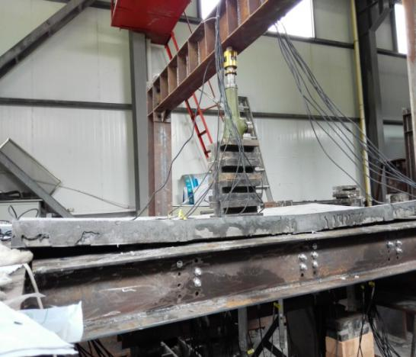
Fig.4 Loading scene of specimens

Test phenomena
It is seen from the results shown in Fig.5 and Fig.6 that all the specimens have better entirety and plastic deformation ability. It is seen that there are obvious local buckling at end of the main steel beam, crack in the corner of specimen SJ1 and evident cracks on top surface and lower surface of concrete panels of specimen SJ2. There is noise during loading for all specimens, but the time for the specimens giving out noise is different.

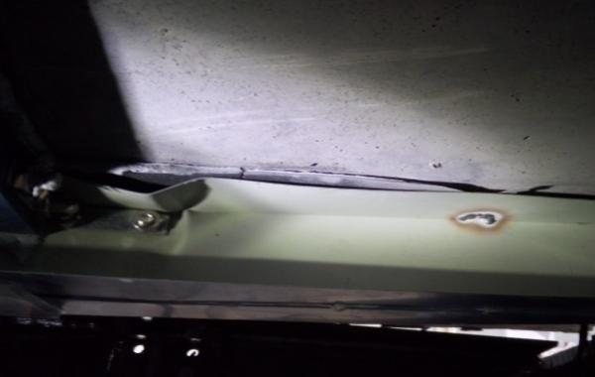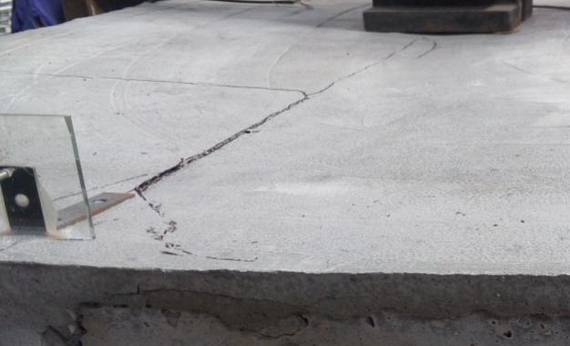
(a) Local buckling at support (b) Crack on top surface of concrete
Fig.5 Failure characteristics of specimen SJ1

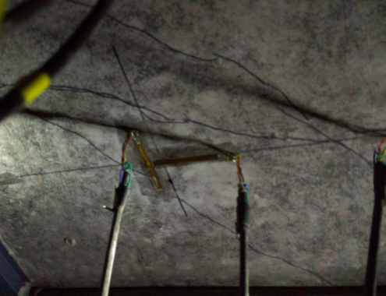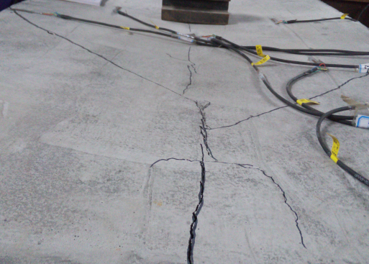
(a) Crack on lower surface of concrete (b) Crack on top surface of concrete
Fig.6 Failure characteristics of specimen SJ2

Displacements and strains of specimens
The comparison of deflection-load curves of three specimens are shown in Fig.7. It is seen that the relation of load P and vertical displacement of the specimens has evident nonlinearity, but the deflection △ at center of specimens varies linearly with the concentrated force P as if the load P is less than 13kN for all specimens, which means that the composite slabs are elastic for the load. It is also seen that the specimen SJ1 has the largest deformation, and the maximum deflection of the specimen is up to 16mm, which shows the better plastic deformation ability of the slab.
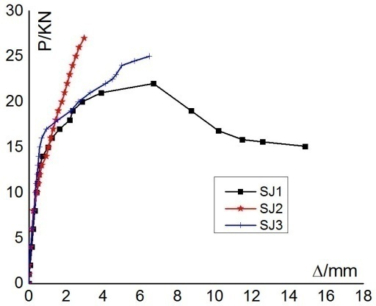
Fig.7 Comparison of P-△ curves of specimens
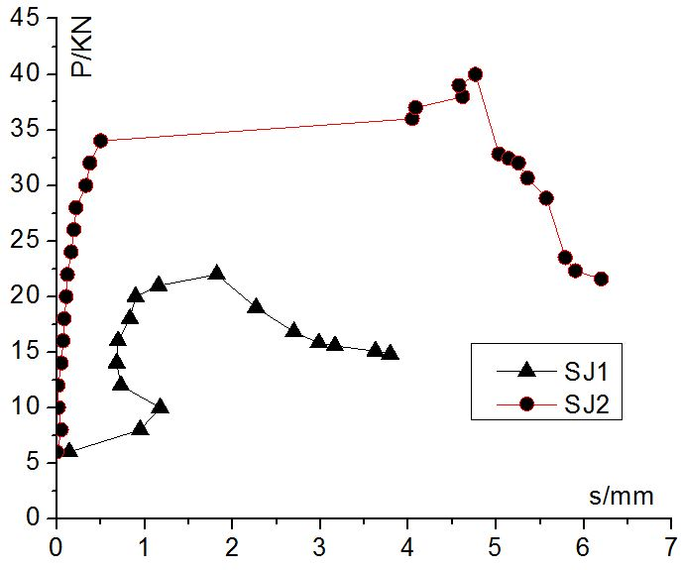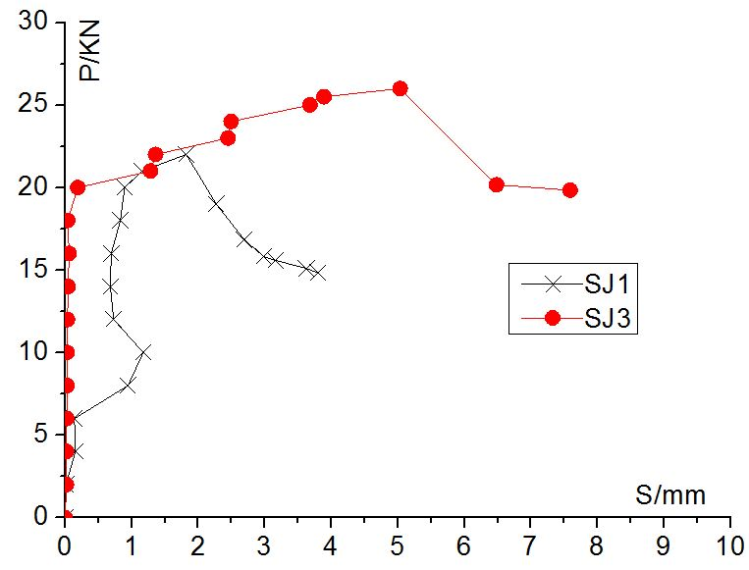
(a) Comparison of SJ1 and SJ2 (b) Comparison of SJ1 and SJ3
Fig.8 Relative slips at hinged-fixed end of specimens

It is seen from the results shown in Fig.8 that the relative horizontal displacements at hinged-fixed end of specimens are all smaller, and the slip of specimen SJ1 was the lest and specimen SJ3 the largest, which means that the relative displacement of steel beam and concrete panel of the specimen with the fixed support condition at two ends is larger.

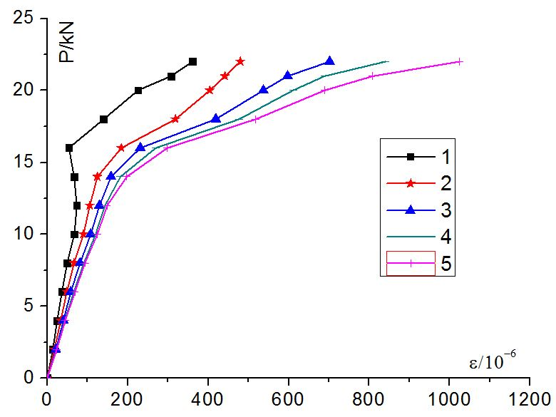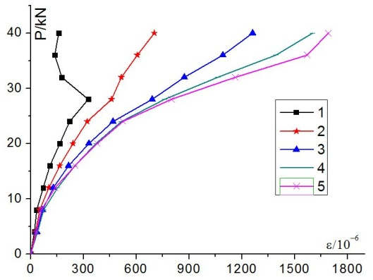
(a) Specimen SJ1 (b) Specimen SJ2

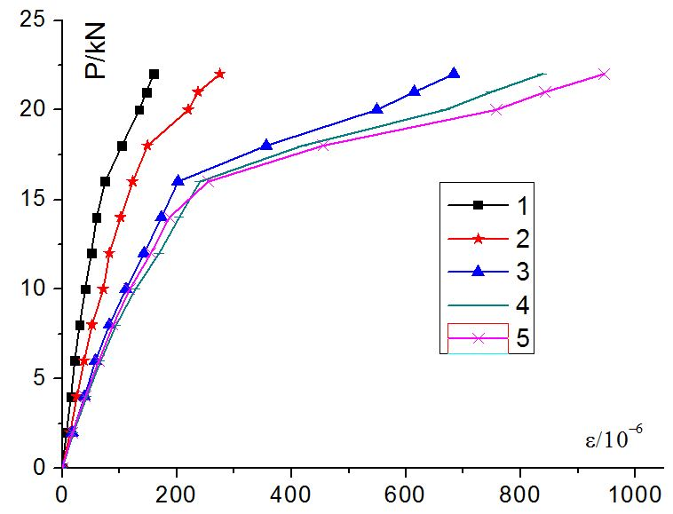
(c) Specimen SJ3
Fig.9 Strain curves of specimen SJ3

It is denoted that the numbers 1~5 shown in Fig.9 represent the measuring points corresponding to the measuring points of strains of cross section of steel beams as shown in Fig.3(c), which mean that the strain for number 1 stands for the mean strain of measuring points 1-1 and 1-2, 2 stands for the mean strain of measuring points 2-1 and 2-2, and so on. It is seen from the curves shown in Fig.9 that the mechanical characteristics are elastic for both of specimen SJ1 and specimen SJ2 as if the load is less than 10kN, however the ultimate elastic load is 15kN for specimen SJ3. The results show that the elastic bearing capacity is greatest for specimen SJ3. It is also shown that specimen SJ2 has the largest bearing capacity and the corresponding ultimate bearing load is 40kN, and the corresponding strain at lower flange of steel beam is 1.8×10⁻³,the results also show that difference of the strain at upper flange and the strain at lower flange of H-type steel beam of the specimen is the largest.
- Conclusion
Based on the results and discussions presented above, the conclusions are obtained as below:
(1) It is shown that all the lightweight aggregate concrete composite slabs have better plastic deformation ability and higher bearing capacity, and the ultimate elastic bearing load is 7.5kN/m², which is much greater than the normal service load of 2kN/m².
(2) The failure forms of the composite slabs involve local buckling of the thin-wall steel beams, overall torsion of the steel beams and through cracks on top surface and lower surface of concrete panel.
(3) It is concluded that the boundary conditions at ends of the specimens has great effect on static mechanical properties of the composite slabs presented here, and the composite slab with restraint at four corners has the largest bearing capacity.
Acknowledgments
This work was financially supported by the Applied Research Project of Public Welfare Technology of Zhejiang Province (2017C33013).
References
- Zhang Yankun, Liu Yanghua, et al. Experimental study on flexural bearing capacity of profiled steel sheet-light-weight aggregate concrtete floor slabs[J]. Industrial Construction, 2008, 38(8):83-85(in Chinese).
- ZHEN Yi, Cheng Shuwei, et al. The caculation of shear slippage of light-weight aggregate concrete composite floor slabs[J].Industrial Construction, 2007,37(s1):579-591(in Chinese).
- Kong Weichao. Experimantal study of light steel truss beam-profiled sheet lightweight concrete composite slabs[D]. Chongqing: Chongqing University,2013:6-38(in Chinese).
- Wu Fangbai, Liu Biao,et al. Analysis of the interlocking effect of the combined interface in a new type of composites floor[J]. Journal of Hunan University, 2014,41(2):1-7(in Chinese).
- Wang Xintang, Yang Jin, et al.Experimental study of mechanical property of thin-walled steel truss –ceramsite concrete composite slabs[J]. Journal of Building Structures, 2016,37(s1): 259-266(in Chinese).

