页面尺寸纸型：A4（宽度：21厘米，高度：29.7厘米），页边距：上4厘米，下2.7厘米，左2.5厘米，右：2.5厘米，文档网格：无网格

（论文中必须要有Introduction，Conclusion）

Experimental research on mechanical performance of the lightweight composite slabs （Times New Roman，字号：17，段前：79.4磅，段28.35磅，加粗）
Hui Zou^{1a*}, Jun Wang^{1b*}, Xin Wang^{1c}（字体为：Times New Roman，字号：11，左侧缩进：2.5厘米，段后：5.65磅）
¹Department of Civil Engineering, Ningbo University, Ningbo 315211, China（单位字体为：Times New Roman，字号：11，左侧缩进：2.5厘米，段后：5.7磅）
^{a*}wxt196322@126.com, ^{b*}123549@163.com, ^{c}25896@163.com（邮箱字体：Times New Roman，字号：11，左侧缩进：2.5厘米，段后：5.7磅）
Abstract—This electronic document is a “live” template. The various components of your paper [title, text, heads, etc.] are already defined on the style sheet, as illustrated by the portions given in this document
Keywords-component; formatting; style; styling; insert
（摘要和关键词字体为：Times New Roman，字号：10，左侧缩进：2.5厘米，段后22.7磅）

- Introduction（一级标题---字体Times New Roman，字号11，段前12磅，加粗）
This template, modified in MS Word 2003 and saved as “Word 97-2003 & 6.0/95 – RTF” for the PC, provides authors with most of the formatting specifications needed for preparing electronic versions of their papers. All standard paper components have been specified for three reasons: (1) ease of use when formatting individual papers, (2) automatic compliance to electronic requirements that facilitate the concurrent or later production of electronic products, and (3) conformity of style throughout a conference proceedings. Margins, column widths, line spacing, and type styles are built-in; examples of the type styles are provided throughout this document and are identified in italic type, within parentheses, following the example. Some components, such as multi-leveled equations, graphics, and tables are not prescribed, although the various table text styles are provided. The formatter will need to create these components, incorporating the applicable criteria that follow.
正文字体：Times New Roman，字号11，标题下的第二段起首行缩进0.5厘米，（注意标题序号必须要阿拉伯数字来表示并且要按照顺序来）
- Construction and Geometrical Dimensions of Specimens
The with H-type main steel beams and steel channels, lightweight precast panels set upon the steel skeleton, shear keys connected to the main steel beams and post-pouring concrete layer.
Fig.1 Construction and geometrical dimensions of specimens
（图片标题：字体Times New Roman字号11 居中，注意图片需要嵌入型以及图片内容要清晰，图片切勿超出版面，图片标题应该放在图的下面）
(a) Cross section of main beam (b) Cross section of steel channel (c) Precast panel
Fig. 2 Geometrical dimensions of elements

It is noted that the main steel beams of three specimens are supported at the support beam as shown in Fig.1. Each secondary beam (steel channel)
- Test Results and Discussions

Description of specimens（二级三级标题—字体Times New Roman，字号11，段前12磅，倾斜）
Static loading tests of three composite slab specimens as shown in Fig.1 are finished. The loading point and the measuring points of displacements are shown in Fig.3.
(a) Measuring points of displacements and loading point

(b) Measuring section of strains (c) Measuring points of strains of
of main steel beam section I-I
Fig.3 Distribution of measuring points of specimens

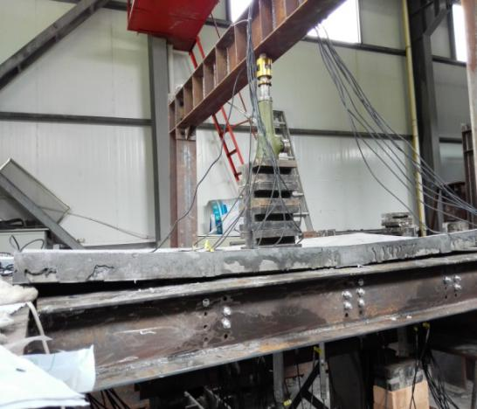
Fig.4 Loading scene of specimens
- Conclusion
Based on the results and discussions presented above, the conclusions are obtained as below:
(1) It is shown that all the lightweight aggregate concrete composite slabs have better plastic deformation ability and higher bearing capacity, and the ultimate elastic bearing load is 7.5kN/m², which is much greater than the normal service load of 2kN/m².
(2) The failure forms of the composite slabs involve local buckling of the thin-wall steel beams, overall torsion of the steel beams and through cracks on top surface and lower surface of concrete panel.
(3) It is concluded that the boundary conditions at ends of the specimens has great effect on static mechanical properties of the composite slabs presented here, and the composite slab with restraint at four corners has the largest bearing capacity.
Acknowledgments
This work was financially supported by the Applied Research Project of Public Welfare Technology of Zhejiang Province (2017xxxxxxx).
References
[1] Van der Geer, J., Hanraads, J.A.J., Lupton, R.A. (2010) The art of writing a scientific article. J. Sci. Commun., 163: 51–59.
[2] Podani, J. (1994) Multivariate Data Analysis in Ecology and Systematics. SPB Publishing, The Hague.
[3] Mettam, G.R., Adams, L.B. (2009) How to prepare an electronic version of your article. In: Jones, B.S., Smith, R.Z. (Eds.), Introduction to the Electronic Age. E-Publishing Inc., New York. pp. 281-304.
[4] Thompson, J.N. (1984) Insect Diversity and the Trophic Structure of Communities. In: Ecological Entomology. New York. pp. 165-178.
[5] Cancer Research UK. (1975) Cancer statistics reports for UK. http://www.cancerreseark.org/aboutcancer/statistics.
（参考文献标题为“References”，加粗，段前12磅，字体Times New Roman，字号11，该标题无需加序号），参考文献正文字体为Times New Roman，字号11，悬挂缩进1.5 厘米

