ACM-为提高文章通过率，请作者严格按照以下标准自检文章版面
页面设置 | 页边距：上：3.1厘米，下：5.01厘米，左：2.54厘米，右：3.6厘米  纸张大小：Letter，宽度：21.59厘米，高度：27.94厘米  无网格
篇幅 | 全文单栏不能低于8页，双栏不能低于5页。
作者 | 请在文中备注所有作者的邮箱，每位作者的邮箱均是唯一的（通讯作者的邮箱必须用符号“*”标记清楚且邮箱必须有效，以便接收签署论文出版版权的邮件。）
CCS | 根据ACM的出版要求，请在正文中关键词的下面补充CCS CONCEPTS部分。CCS操作如下：登录https://dl.acm.org/ccs选择,根据自己研究方向选择类目，复制张贴CCS中所选类目的文字。并将CCS的代码复制在文件的备注栏（请参考ACM-2的操作指引）。
Keywords | 至少3个关键词。
字体 | 全文字体： Linux Biolinum O；字号：小五；两端对齐（除专有名词、所有一级标题、以及首句首首字母字母大写以外，其余单词全部小写）
标题 | Paper Title (字号小四 ，加粗，左对齐)
 | 一级标题格式统一（大写，字号 小五，加粗）
 | 二级标题格式统一（字号 小五，加粗）
 | 三级标题格式统一（字号 小五，斜体，加粗）
图片 | 图：图片必须要高清（阅读模式在100%的比例下能清晰读取图中的文本数据），且图片中不能有中文字符。
 | 图：每张图片仅对应一个标题，如果有多张照片，请将多张照片整合成一张。
 | 图片标题：字号 8，居中（所有“Figure”不能缩写，标题末尾需要加句号）。所有图片必须要在正文中引用，且按阿拉伯数字顺序排序（如 Figure 1、2、3......）
表格 | 表格标题：字号 8，居中（所有“Table”不能缩写，标题末尾需要加句号）
 | 所有表格必须要在正文中引用，且按阿拉伯数字顺序排序（如 Table 1、2、3......）
公式 | 所有公式必须使用 mathtype或者Word自带的编辑器创建，其它工具创建均无效。
 | 所有公式均需要可编辑格式，且阿拉伯按顺序排序。（如：(1)、(2)、(3)......）
文献 | 所有文献必须注明出版年份。
 | 参考文献不能低于5条，且被引用的文献作者来源应来自三个或者三个以上国家，参考文献在正文中的引用需要以“^{[阿拉伯数字]}”上标的形式标注。
PS：请联系所有共同作者提供唯一的ORCID号备用，后续签署出版协议的时候需要填写此信息。如果没有，可提前访问此链接创建：https://orcid.org/register
*由于ACM的排版要求比复杂，所以作者只要确保以上需要注意的地方均按照要求核实无误即可，文章交付出版前，排字编辑将会按照出版物的要求进行排版，并会联系作者确认终稿。

CCS张贴指引：
- 访问CCS链接：https://dl.acm.org/ccs
- 根据文章的研究方向，选择符合文章内容相关主题的（三级）类目
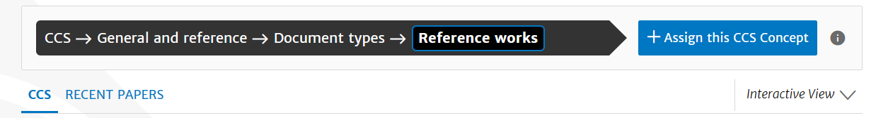
- 张贴CCS（复制即可，不要进行任何更改）。
CCS CONCEPTS
General and reference ~ Document types ~ Document types
- 复制代码
  - 选择类目
  - 添加CCS
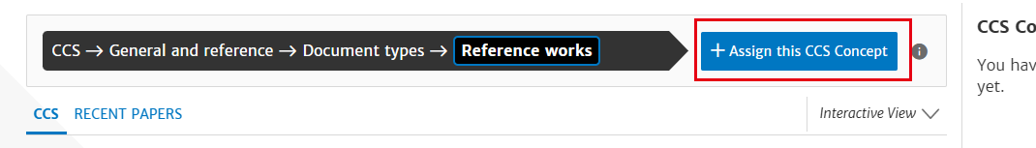
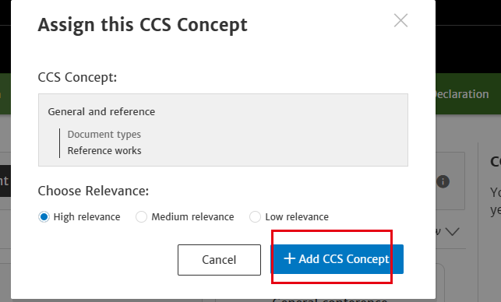

  - 创建代码
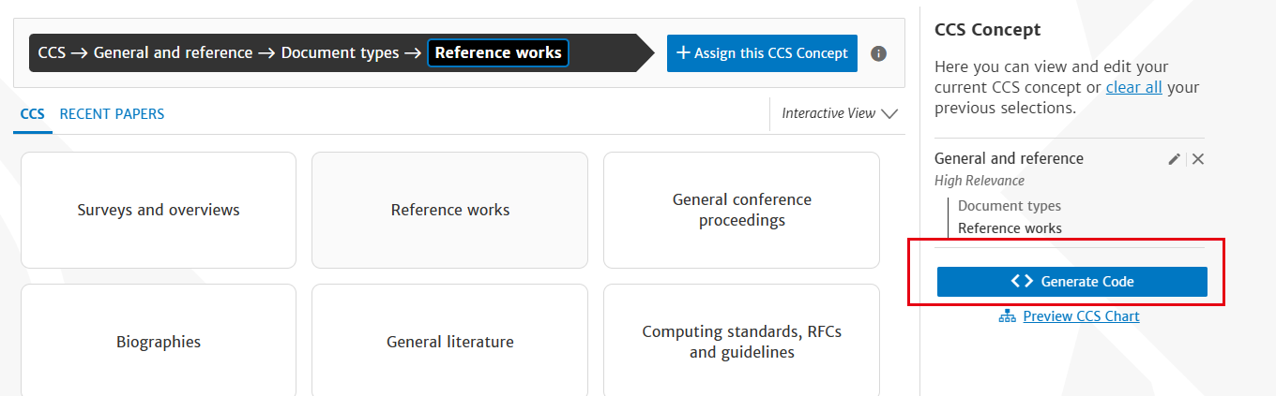
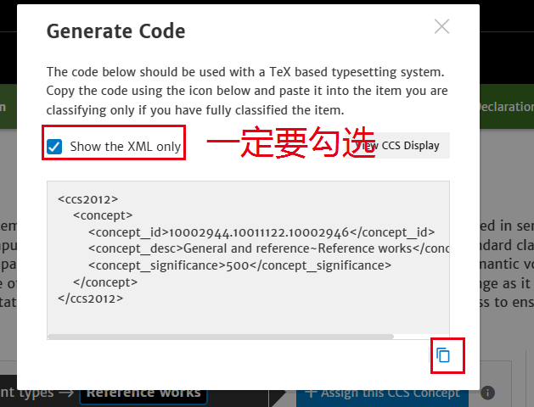
  - 复制代码至备注栏。^{备注路径：“文件”→“信息”→“备注”。}
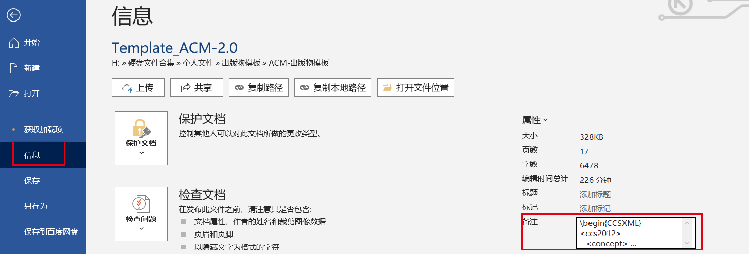

Submission Template for ACM Papers
First Author's Name *（此标记一定是通讯作者的邮箱，不可进行任何更改，要确保能接收签署版权的邮件）
First author's affiliation, an Institution with a very long name, city, post number, Country, xxxx@gmail.com
Second Author's Name
First author's affiliation, an Institution with a very long name, city, post number, Country, xvvx@gmail.com
Third Author's Name
First author's affiliation, an Institution with a very long name, city, post number, Country, xaaaxx@gmail.com
Abstract
Although there is no distinctive header, this is the abstract. This submission template allows authors to submit their papers for review to an ACM Conference or Journal without any output design specifications incorporated at this point in the process. The ACM manuscript template is a single column document that allows authors to type their content into the pre-existing set of paragraph formatting styles applied to the sample placeholder text here. Throughout the document you will find further instructions on how to format your text. If your conference’s review process will be double-blind: The submitted document should not include author information and should not include acknowledgments, citations or discussion of related work that would make the authorship apparent. Submissions containing author identifying information may be subject to rejection without review. Upon acceptance, the author and affiliation information must be added to your paper.
CCS CONCEPTS
General and reference ~ Document types ~ Document types
Keywords
Keyword number 1, Keyword number 2, Keyword number 3, Keyword number 4
- Introduction
ACM's new manuscript submission template aims to provide consistent styles for use across ACM publications, and incorporates accessibility and metadata-extraction functionality necessary for future Digital Library endeavors. Numerous ACM and SIG-specific templates have been examined, and their unique features incorporated into this single new template. If you are new to publishing with ACM, this document is a valuable guide to the process of preparing your work for publication. If you have published with ACM before, this document provides insight and instruction into the current process for preparing` your manuscript.
  - Accessibility
Following the guidelines throughout this template will also improve the accessibility of your manuscript and increase the audience for your work. Ensure that heading styles are applied as instructed, tables are created using Word’s table feature (rather than an image), figures have a text equivalent, and list styles are applied as instructed.
    - More about the submission template. （一定要句号）
This submission version of your paper should not have headers or footers, these will be added when your manuscript is processed after acceptance. It should remain in a one-column format—please do not alter any of the styles or margins.
- Inserting Content Elements
The next subsections provide instructions on how to insert figures, tables, and equations in your document.
  - Tables
Tables are “float elements” which should be inserted after their first text reference and have specific styles for identification. Do not use images to present tables, or they will be inaccessible to readers using assistive technologies.
Table 1. Styles available in the Word template.
Style Tag | Definition | Style Tag | Definition
Title_document | main title of article | ListParagraph | list items
Subtitle | subtitle of article | Statements | math statements
Authors | author name | Extract | block quotations
Affiliation | author affiliation information | Algorithm Caption | caption for algorithm
AuthNotes | footnote to author(s) | AckHead | heading for acknowledgements
Abstract | abstract text | AckPara | acknowledgements text
CCSHead | heading for CSS Concepts | GrantSponsor | sponsor of grant
CCSDescription | CSS terms | GrantNumber | number for the grant
KeyWordHead | heading for keywords | ReferenceHead | heading for references
Keywords | keywords text | Bib_entry | references
ORCID | author's ORCHID # | AppendixH1 | appendix heading level 1
Head1 | heading level 1 | AppendixH2 | appendix heading level 2
Head2 | heading level 2 | AppendixH3 | appendix heading level 3
Head3 | heading level 3 | TableCaption | title of table
PostHeadPara | first paragraph after a heading | TableHead  TableFootnote | column head of table  footnote to table
Para | Subsequent paragraphs of general text | Image | figures
ParaContinue  DisplayFormula | flush left text after display items like math equations, lists etc.  numbered math equation | DOI | Digital object identifier
DisplayFormulaUnnum | unnumbered equations | Label | labelª
ComputerCode | Display Computer codes | In-text code | intext computer code
Short Title | Short title of article
  - Figures
Figures are “float elements” which should be inserted after their first text reference, and have specific styles for identification. Insert a figure and apply the “Image” paragraph style to it. For the figure caption, apply the style “FigureCaption.”
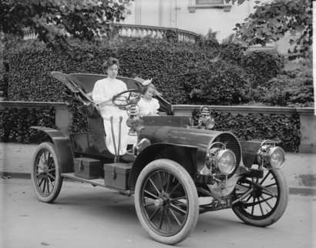
Figure 1. 1907 Franklin Model D roadster. Photograph by Harris & Ewing, Inc. [Public domain], via Wikimedia Commons. (https://goo.gl/VLCRBB)
Figure 3. The layout of multipart images should be as per the above example within the table. All images must have the “Image” style applied.
  - Equations
There are two types of math equations: the numbered display math equation and the un-numbered display math equation. Below are examples of both.
    - DisplayFormula.
The DisplayFormula style is applied in the numbered math equation. A numbered display equation always has an equation number (label) on the right.
$\frac{x=-b±\sqrt{b^{2}-4ac}}{2a}$ (1)
  - Algorithms（算法不要放在表格中）
Algorithms use the styles “AlgorithmCaption” and “Algorithm”.
ALGORITHM 1: Iterative Algorithm
current_position center
current_direction up
current_position is inside circle
while current_position is inside circle, do
neighborhood all grid hexes within two hexes from current_position
for each hex in neighborhood, do
for each neuron in hex do
convert neuron_orientation to vector
scale vector by neuron_excitation
vector_sum vector_sum + vector
end
end
normalize vector_sum
end
- conclusion
Acknowledgments are placed before the references. Add information about grants, awards, or other types of funding that you have received to support your research. Author can capture the grant sponsor information, by selecting the grant sponsor text and apply style ‘GrantSponsor’. After this, select grant no and apply ‘GrantNumber’ from style panel. Example of Grant sponsor: Competitive Research Programme and example of Grant no: CRP 10-2012-03.
ACKNOWLEDGMENTS
Acknowledgments are placed before the references. Add information about grants, awards, or other types of funding that you have received to support your research. Author can capture the grant sponsor information, by selecting the grant sponsor text and apply style ‘GrantSponsor’. After this, select grant no and apply ‘GrantNumber’ from style panel. Example of Grant sponsor: Competitive Research Programme and example of Grant no: CRP 10-2012-03.
REFERENCES（一定要有出版年份）
- Atul Adya, Paramvir Bahl, Jitendra Padhye, Alec Wolman, and Lidong Zhou. 2004. A multi-radio unification protocol for IEEE 802.11 wireless networks. In Proceedings of the IEEE 1st International Conference on Broadnets Networks (BroadNets’04) IEEE, Los Alamitos, CA, 210–217. https://doi.org/10.1109/BROADNETS.2004.8.
- Sam Anzaroot and Andrew McCallum. 2013. UMass Citation Field Extraction Dataset. Retrieved May 27, 2019 from http://www.iesl.cs.umass.edu/data/data-umasscitationfield.
- Martin A. Fischler and Robert C. Bolles. 1981. Random sample consensus: a paradigm for model fitting with applications to image analysis and automated cartography. Commun. ACM 24, 6 (June 1981), 381–395.

