The main international airports in Spain are “Adolfo Suárez Madrid-Barajas International Airport” (recommended) and “Josep Tarradellas Barcelona-El Prat International Airport”. There is also a small airport in the City of Valladolid that offers connections to and from Barcelona and Paris.

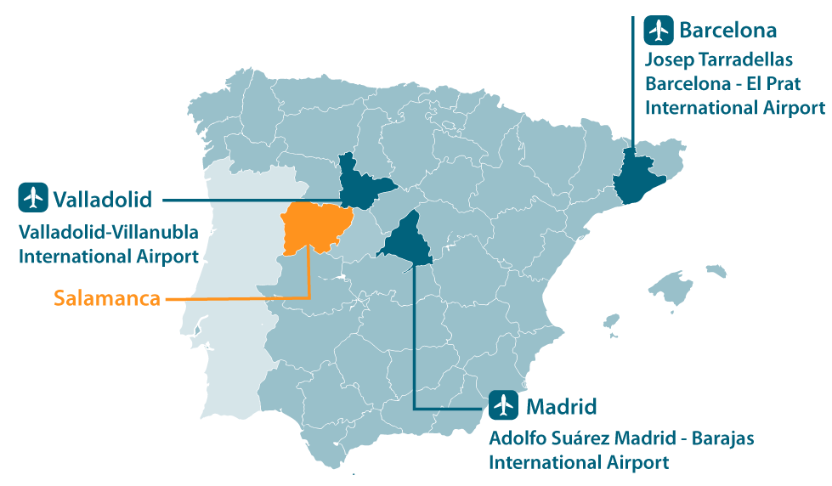

CONNECTIONS FROM MADRID INTERNATIONAL AIRPORT (ADOLFO SUARED MADRID-BARAJAS) TO SALAMANCA

## Madrid-Airport to Salamanca by bus

The bus company AVANZA ([www.avanzabus.com](https://www.avanzabus.com/)) offers a bus service from Madrid Airport to Salamanca bus station. The estimated travel time is 2 hours and 30 minutes.

This service departs from the bus terminals located in Terminal T1 and T4 of Madrid Airport.

* In T1 the bus stop is located in the bus parking area, in front of the T1 Arrivals area, floor 0.
* In T4 the bus stop is located next to module F of Parking P4.

## Madrid (city center) to Salamanca (by train)

You can travel to Salamanca by train from Madrid. There are departures from “Principe Pio” Station or “Chamartín” Station” (faster).

For moving between Madrid airport and the Railway stations there is a suburban train that offers this connection. If you arrive to Madrid Airport Terminal T1, T2 or T3 you will need to take a free shuttle bus to take you to Terminal T4. Its frequency is every 5 minutes.

Once in Terminal T4 you can take a suburban train (“Renfe Cercanías”), lines **C1** or **C10** heading Principe Pío or Chamartín train station to catch your train to Salamanca. The train station is on the terminal T4 floor -1, and is called Aeropuerto T4.

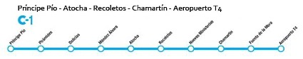



Estimated travel time: Príncipe Pío - Aeropuerto T4 => 41 minutes.

Estimated travel time: Chamartín - Aeropuerto T4 => 15 minutes.

If you arrive in Barcelona, you will need to take a connecting flight to Madrid or Valladolid. Please, refer the information below about the connections between Valladolid and Salamanca, in case you decided to travel to Valladolid airport.

CONNECTIONS FROM BARCELONA AIRPORT TO SALAMANCA

If you arrive in Barcelona, you will need to take a connecting flight to Madrid or Valladolid. Please, refer the information below about the connections between Valladolid and Salamanca, in case you decided to travel to Valladolid airport.

CONNECTIONS FROM VALLADOLID AIRPORT TO SALAMANCA

Salamanca is 115 Km southeast of Valladolid and there is a bus and train service from the city centre. From Valladolid Villanubla airport you can easily get to the train station by taxi or bus [http://www.linecar.es/pdf/Horarios%20Aeropuerto%20Villanubla.pdf](https://linecar.es/wp-content/uploads/horarios/metropolitano/valladolid/VALLADOLID-VILLANUBLA-AEROPUERTO.pdf)

Regular bus ([www.avanzabus.com](http://www.avanzabus.com/web/Aeropuerto-de-barajas/salamanca.html?lang=en)) and train services ([http://www.renfe.com](http://www.renfe.com/)) are available from Valladolid (city centre) to Salamanca. The journey (via highway) between Valladolid and Salamanca takes 1.05 hours.